**Spring data JPA part 2**

**-Akanksha Tyagi**

**id-4701**

**JPQL:**

**Instructions for JPQL and Native SQL Query**

Create an employeeTable table with the following fields: empId, empFirstName, empLastName, empSalary, empAge.

Create an Employee entity having following fields: id, firstName, lastName, salary, age which maps to the table columns given in above.

**1. Display the first name, last name of all employees having salary greater than average salary ordered in ascending by their age and in descending by their salary.**

EmployeeRepository:

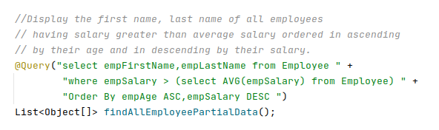

EmployeeService:

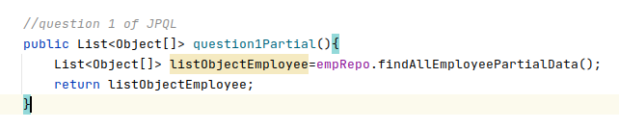

EmployeeController:

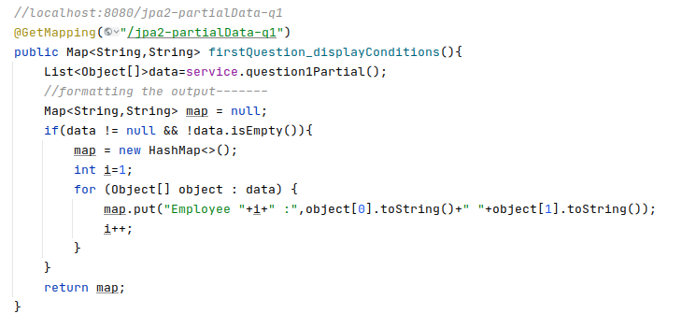

**Output:** <http://localhost:8080/jpa2-partialData-q1>

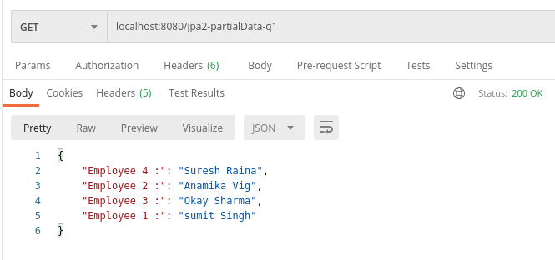

**-------------------------------------------------------------------------------------------------------------------------**

**2: Update salary of all employees by a salary passed as a parameter whose existing salary is less than the average salary.**

EmployeeRepository:

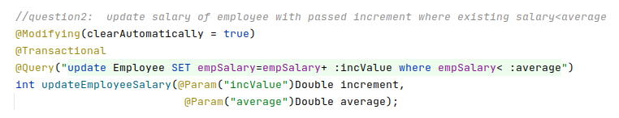

EmployeeService:

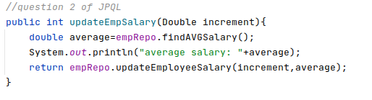

EmployeeController:

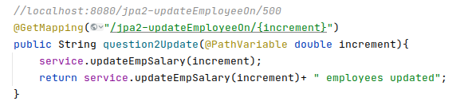

**Output:** <http://localhost:8080/jpa2-updateEmployeeOn/1000> 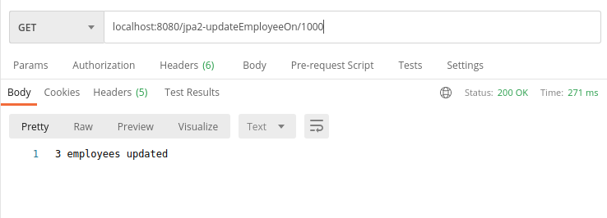

Sql: before updating the salary:

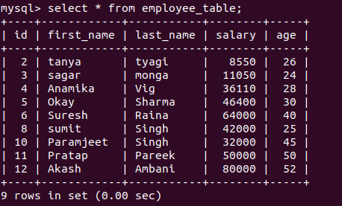

After updating the salary:

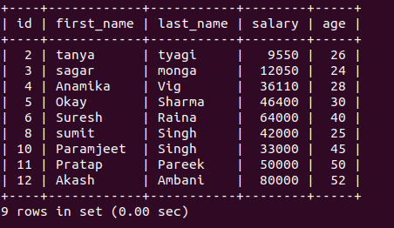

**-------------------------------------------------------------------------------------------------------------------------**

**3. Delete all employees with minimum salary.**

EmployeeRepository:

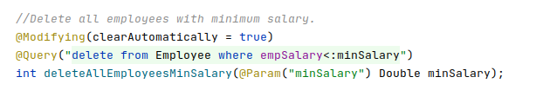

EmployeeService:

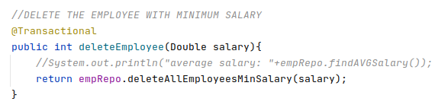

EmployeeController:

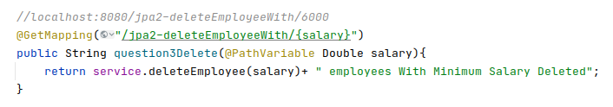

**Output:**

[http://localhost:8080/jpa2-deleteEmployeeWith/6000](http://localhost:8080/jpa2-deleteEmployeeWith/10000) 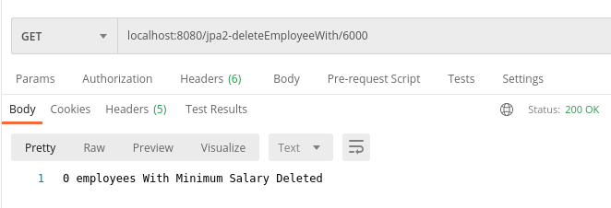<http://localhost:8080/jpa2-deleteEmployeeWith/10000> 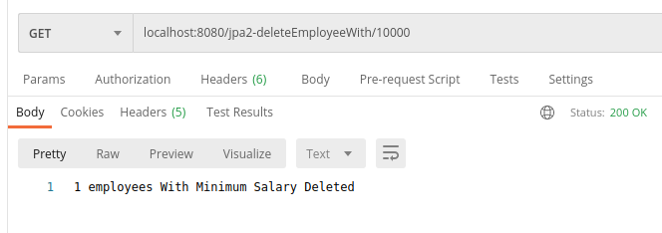

**Sql:**

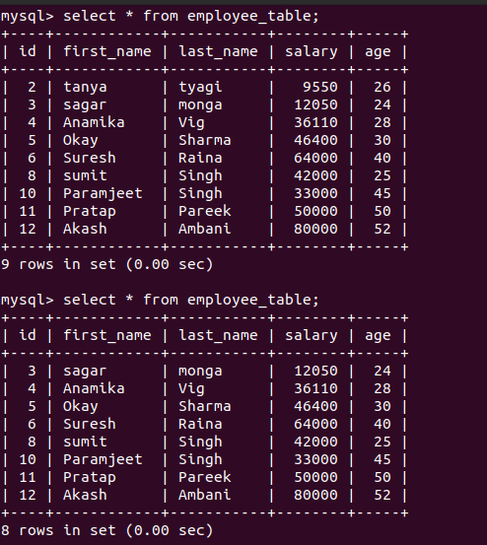

**-------------------------------------------------------------------------------------------------------------------------**

**Native Query:**

**1. Display the id, first name, age of all employees where last name ends with "singh".**

EmployeeRepository:

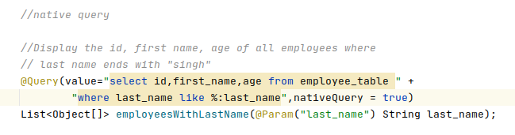

EmployeeService:

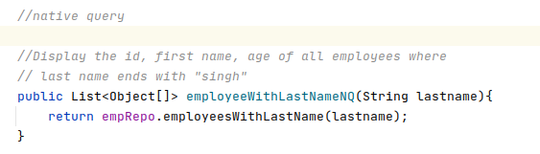

EmployeeController:

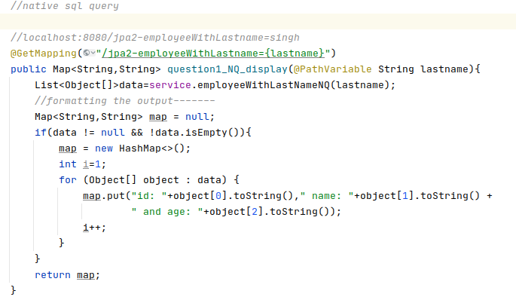

**Output:** <http://localhost:8080/jpa2-employeeWithLastname=singh>

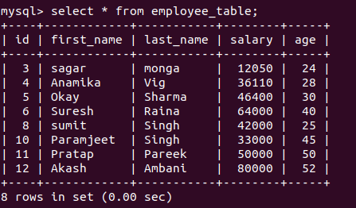

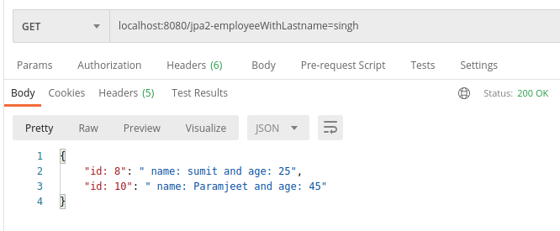

**-------------------------------------------------------------------------------------------------------------------------**

**2. Delete all employees with age greater than 45(Should be passed as a parameter).**

EmployeeRepository:

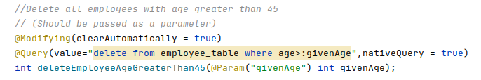

EmployeeService:

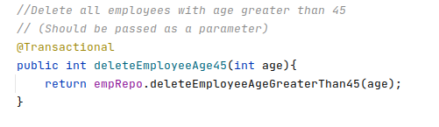

EmployeeController:

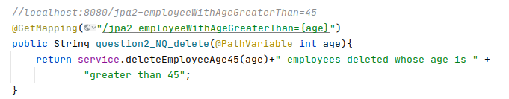

**Output:** <http://localhost:8080/jpa2-employeeWithAgeGreaterThan=45>

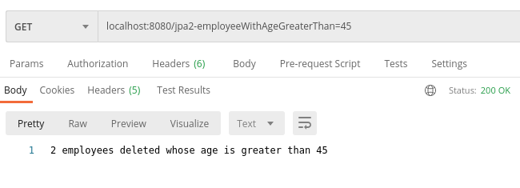

Sql :

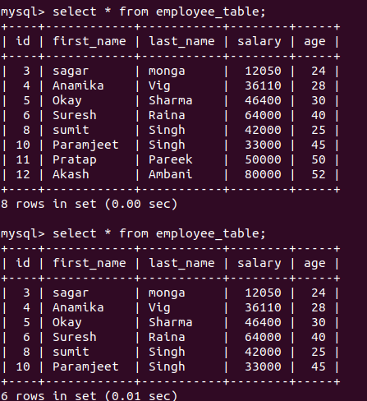

**-------------------------------------------------------------------------------------------------------------------------**

**Inheritance Mapping:**

**1. Implement and demonstrate Single Table strategy.**

Payment.java

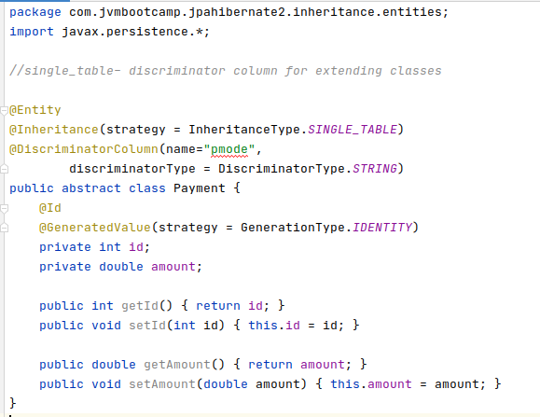

Cheque.java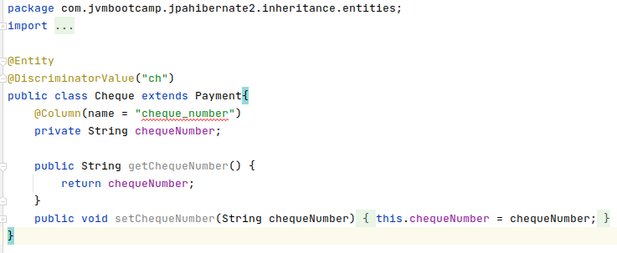

CreditCard.java

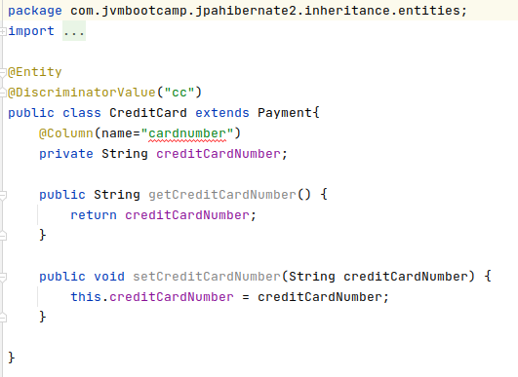

PaymentRepository.java

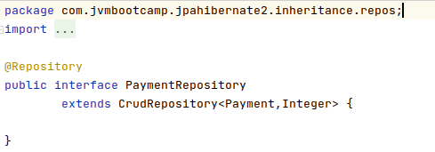

PaymentService.java

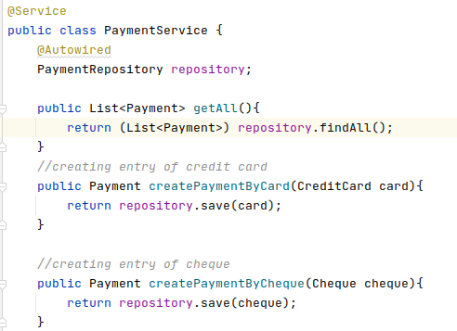

PaymentController.java

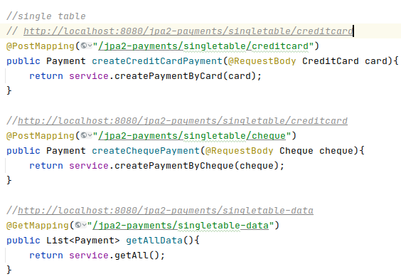

Output:

credit card: <http://localhost:8080/jpa2-payments/singletable/creditcard> (in post)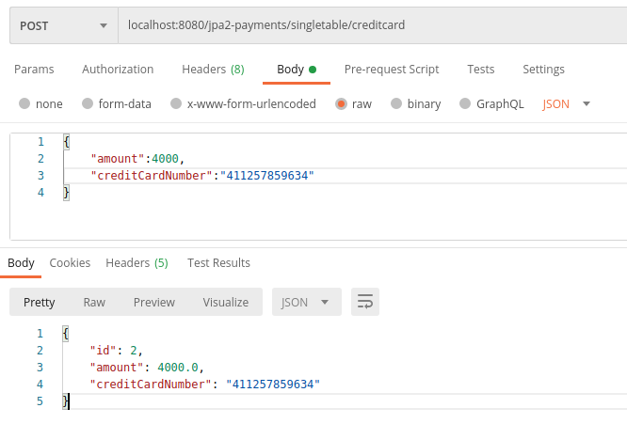Cheque:<http://localhost:8080/jpa2-payments/singletable/cheque> (in post) 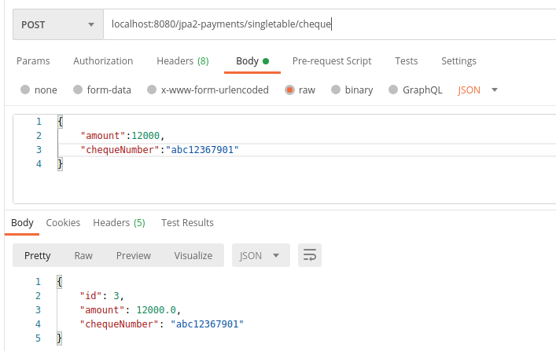

getAllData: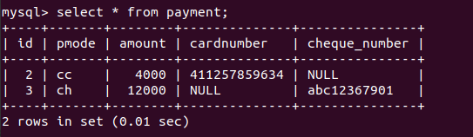

**-------------------------------------------------------------------------------------------------------------------------**

**2. Implement and demonstrate Joined strategy.**

Payment.java

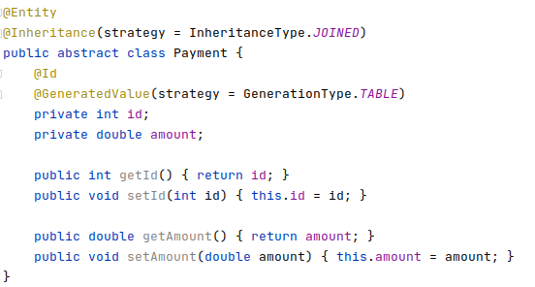

Cheque.java

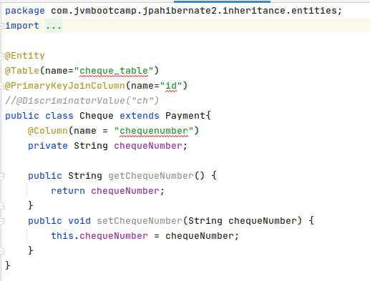

CreditCard.java

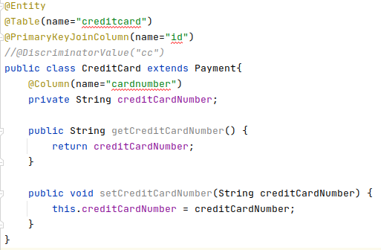

PaymentController.java:

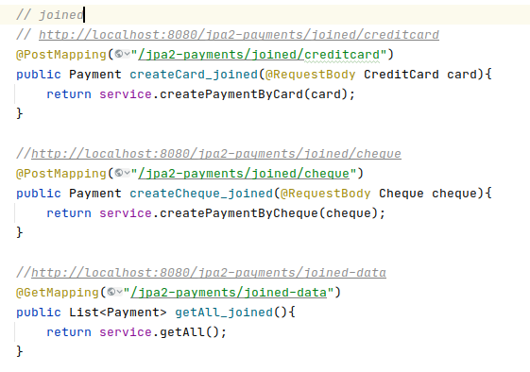

PaymentService.java



Output: 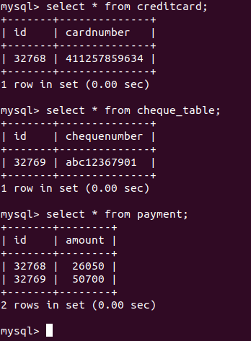



Output: <http://localhost:8080/jpa2-payments/joined/cheque> (in post)

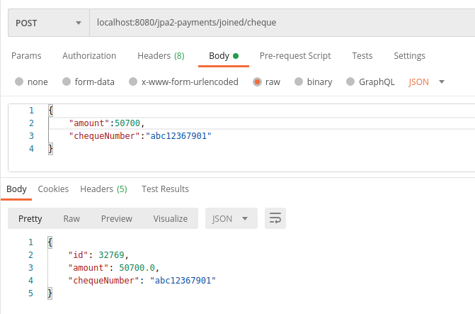

<http://localhost:8080/jpa2-payments/joined/creditcard> (in post)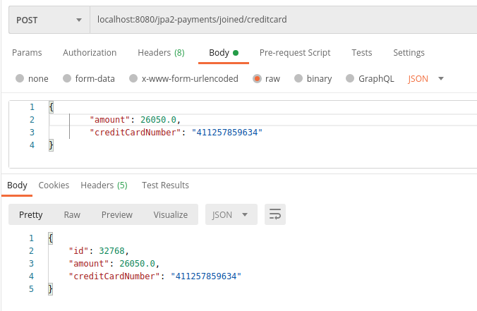

**-------------------------------------------------------------------------------------------------------------------------**

**3. Implement and demonstrate Table Per Class strategy.**

**Edit application.properties as follows:**

***[ #this is for table per class inheritance***

**spring.jpa.hibernate.ddl-auto = update ]**

Payment.java

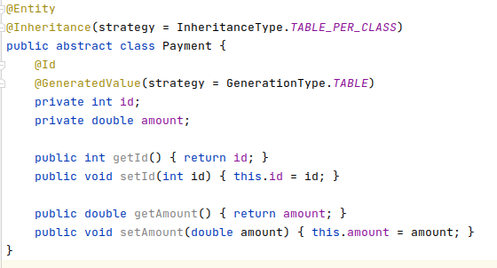

Cheque.java

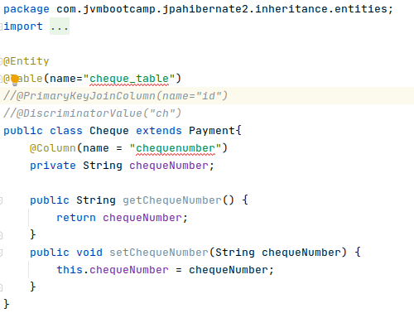

CreditCard.java

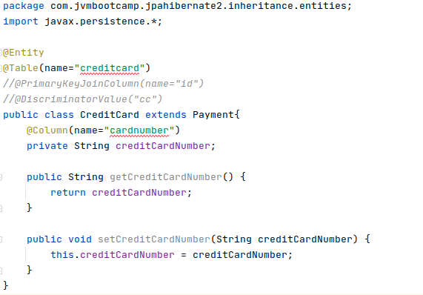

PaymentController.java

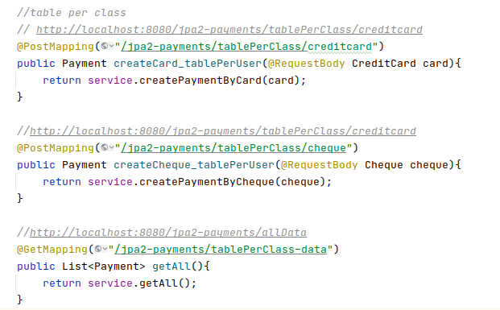

PaymentService.java



Output:

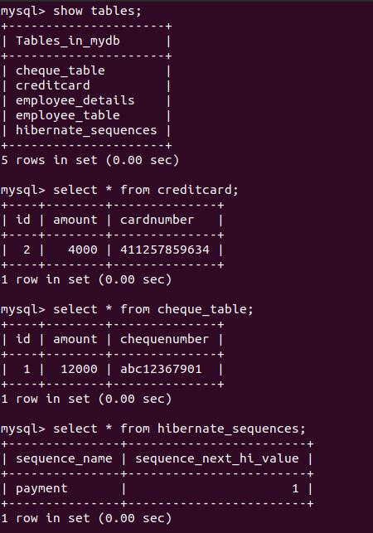

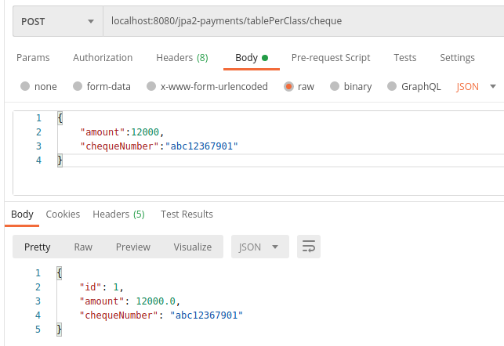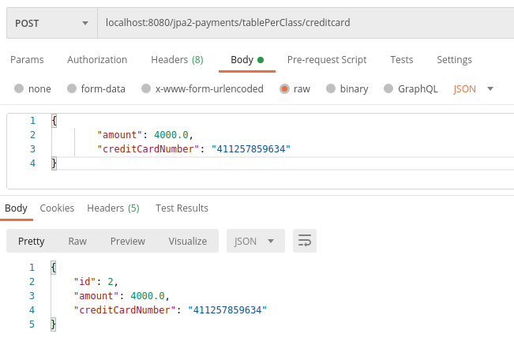

**-------------------------------------------------------------------------------------------------------------------------**

**Component Mapping:**

**1. Implement and demonstrate Embedded mapping using employee table having following fields: id, firstName, lastName, age, basicSalary, bonusSalary, taxAmount, specialAllowanceSalary.**

EmployeeMapping.java

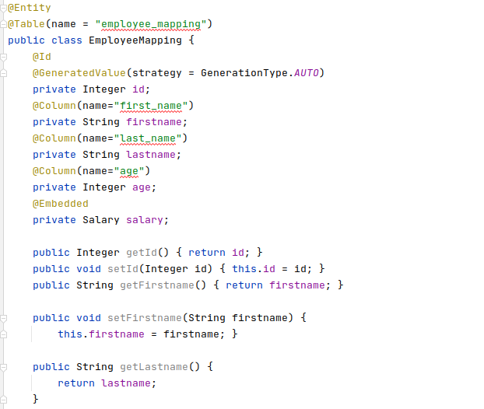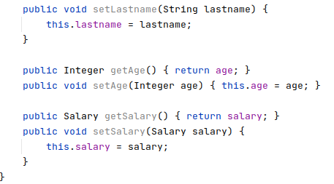

Salary.java

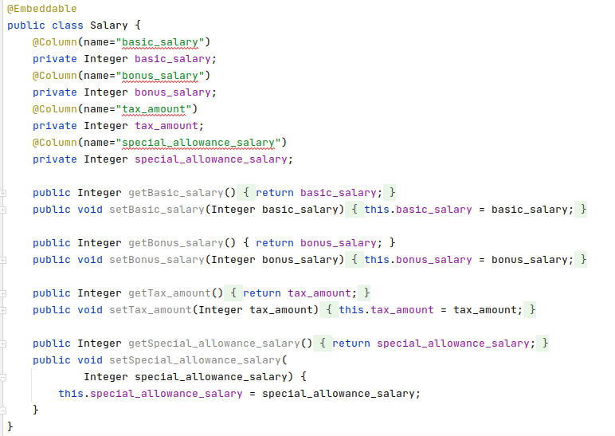

EmployeeSalaryRepository.java

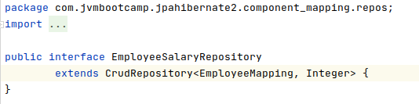

EmployeeSalaryService.java

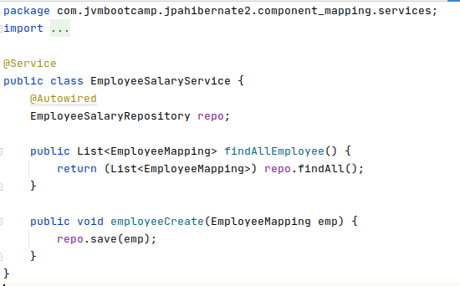

EmployeeSalaryController.java

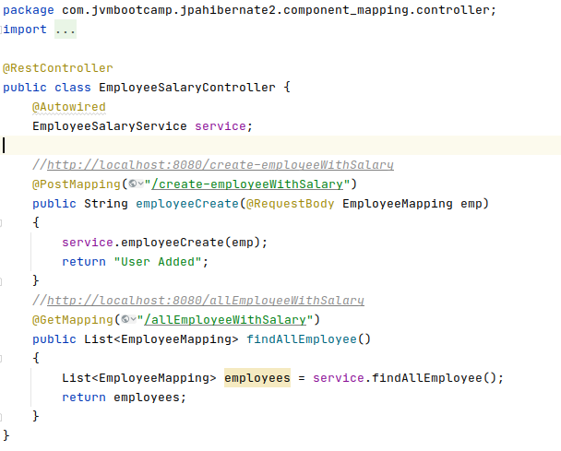

**Output:**

Creating employee with salary:

<https://localhost:8080/create-employeeWithSalary> (in post)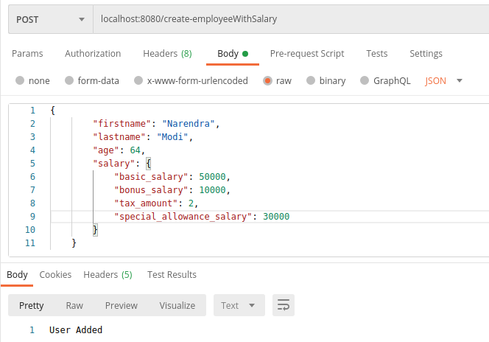

Getting employee details with salary break down:

<http://localhost:8080/allEmployeeWithSalary>

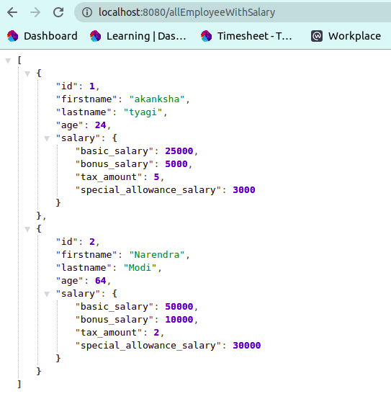

Sql: 

